# **10.6 Guided Exercise: Learning about Vulnerabilities**

|  |  |
| --- | --- |
| **Resources** | |
| Files | None |
| Machines | None |

In this exercise you will identify details regarding a specific vulnerability. You will need to use a web browser for this exercise not in the lab environment.

Open a web browser and type the following link [https://cve.mitre.org](https://cve.mitre.org/).

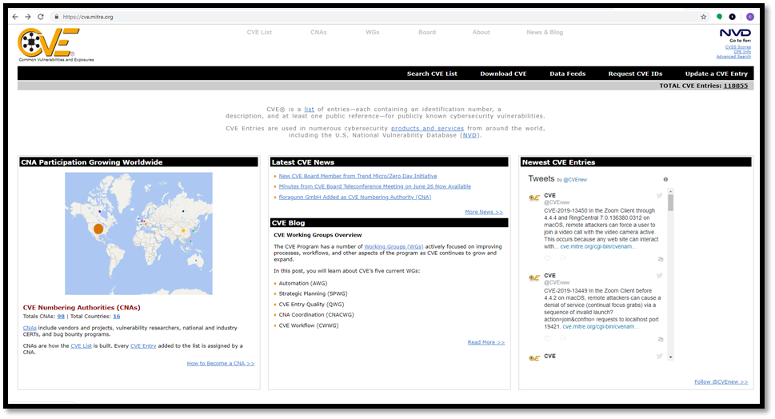

From the menu click on Search CVE List. In the search box enter CVE-2019-0708 and click on Submit.

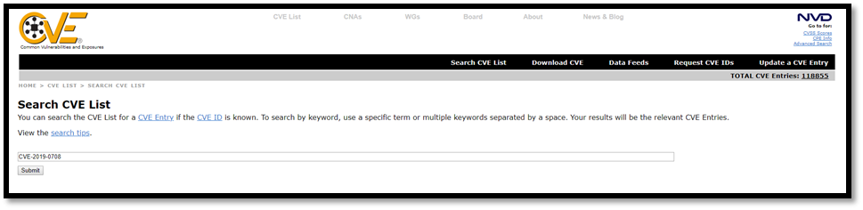

One entry will be returned and click on it to learn more about that specific vulnerabilitiry.

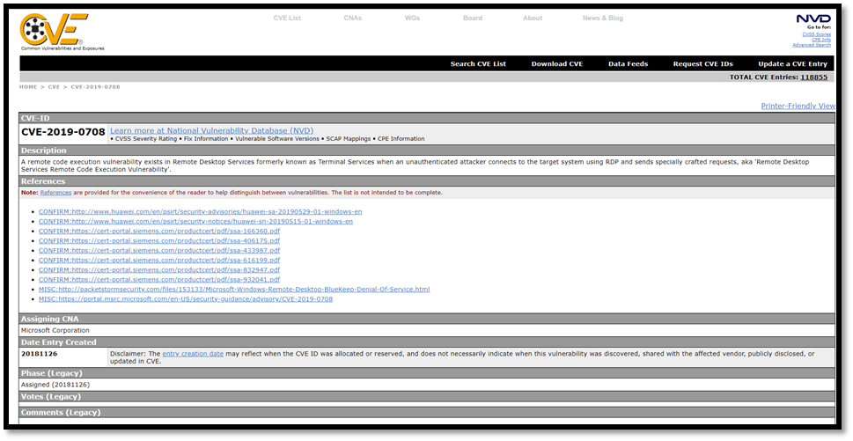

Read the description carefully and you will note that the vulnerability affects the Remote Desktop Services on Windows machines.